REPORT SD201 TP2

Question 1:
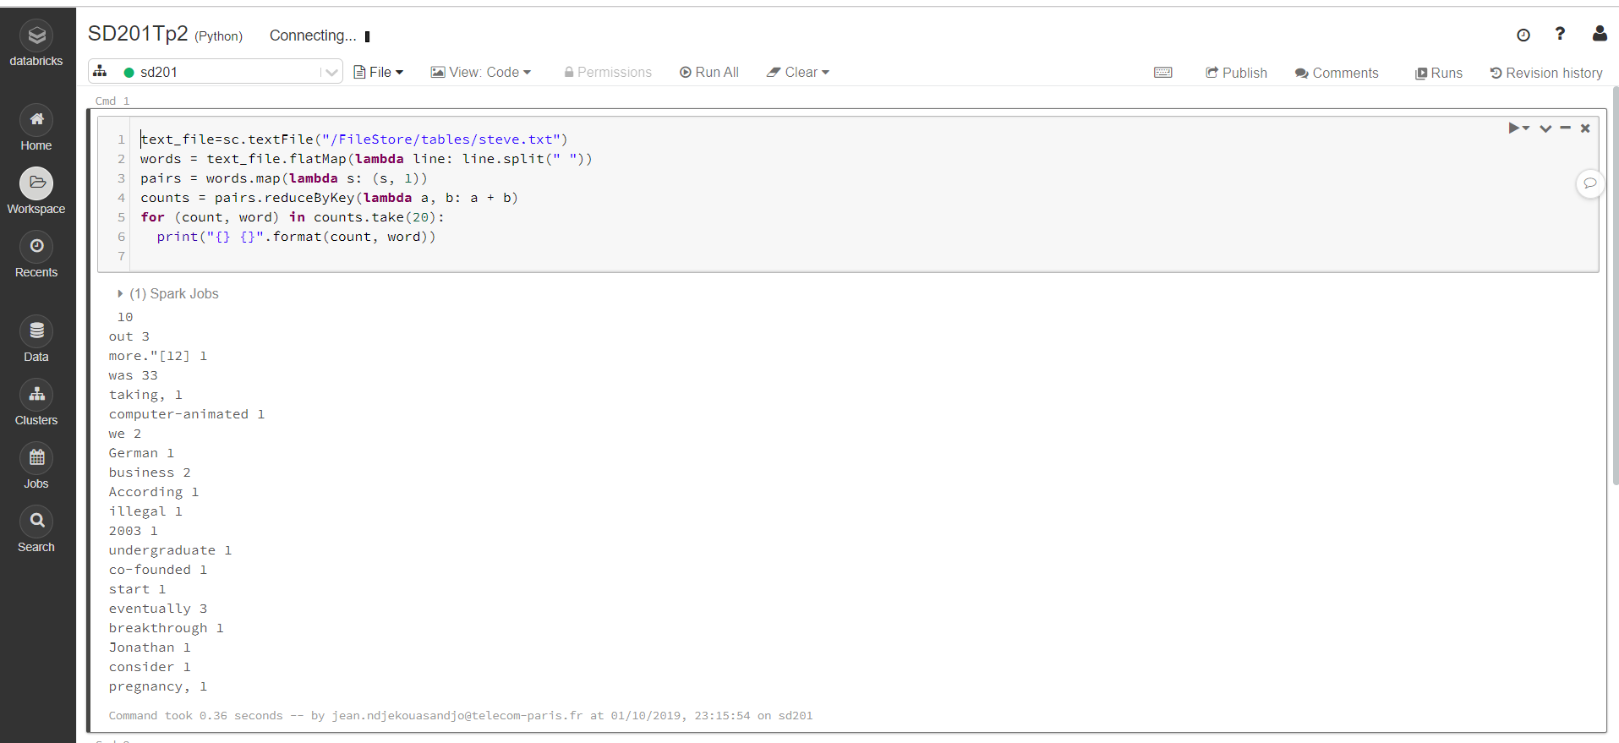
#1)mofified c into sc and defined the variable text_file which stores the lines of the text
#2)modified the print format because the previous one was giving some errors
#3)modified the map from (s,2) to (s,2)

Question 2:
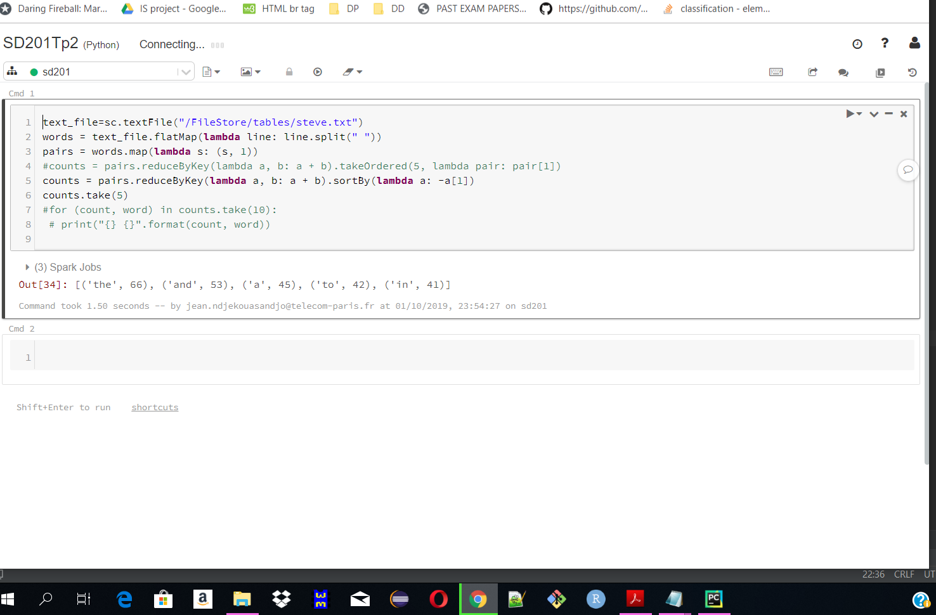

Question 3:
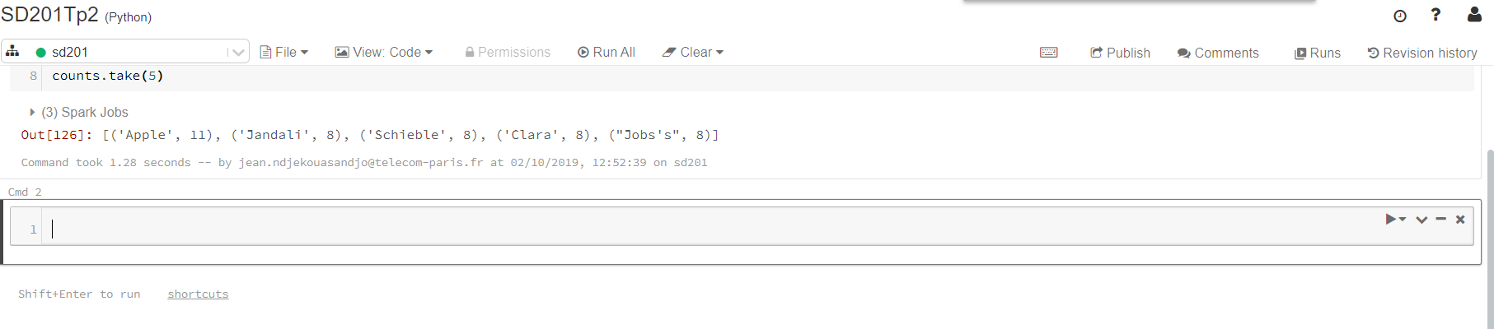

Question 4:
